Microgrid Design and Simulation Project on Atlantic Salt Refinery Boat

Group Members:

Dhaman Pappulla Laxmipathy

Nathan Raschkes

Sohan Jackson Chembakassery

**Location of the microgrid and local cost of diesel fuel:**

Port of New York City, New York to Port of London, England

**Type of load:** Industrial

**Amount of load (kWh per day):** 56,121kWh/day

**Cost of energy storage:** $49,140

Source: <https://www.energysage.com/local-data/energy-storage-cost/ca/>

**Cost of PV:** $22,000

Source: [https://www.empower-solar.com/en/home-solar/solar-panel-cost/#:~:text=The%20cost%20of%20an%20average,%242.92%20to%20%244.20%20per%20watt.](https://www.empower-solar.com/en/home-solar/solar-panel-cost/%23:~:text=The%20cost%20of%20an%20average,%242.92%20to%20%244.20%20per%20watt.)

**Cost of Wind:** $5,353

Source: <https://www.empirecenter.org/publications/new-wind-energy-blows-doors-off-projections/>

**Cost of diesel fuel:** $127,000

Source: [https://maritimepage.com/fuel-consumption-how-much-fuel-cargo-ship-use/#Overview_of_Cargo_Ship_Fuel_Consumption](https://maritimepage.com/fuel-consumption-how-much-fuel-cargo-ship-use/%23Overview_of_Cargo_Ship_Fuel_Consumption)

**Parameters used for homer setup:**

**Cost of diesel:** you can use the default of $1/liter.

**Electrical load:** 60,000kWh

**Wind turbine:**

Assume a 100 kW XANT turbine

Assume a cost of $1/W for wind turbines

**Battery:**

Use generic 1 kWh lithium ion batteries.

Use $130 per battery.

**Microgrid Description and Overview**

Syracuse, New York has been well known as the “salt capital.” Since New York is a leading producer of salt, we have established a means of transportation via a bulk carrier that has been dubbed the salt refinery boat. This vessel produces and purifies salt through a refining process, which will be exported from the port of New York in New York City to the port of London in England

**Offshore Wind Turbines:**

High-efficiency offshore wind turbines harness the kinetic energy of wind to generate electricity, providing a continuous and substantial power source for the microgrid.

**Solar PV Cells:**

Integrated solar PV cells convert sunlight into electrical energy during daylight hours, complementing the wind turbines and contributing to a well-balanced renewable energy mix.

**Energy Storage Solutions:**

State-of-the-art energy storage, such as advanced battery systems, stores excess energy generated during periods of high wind or sunlight. This stored energy is then released during periods of low renewable energy production or peak demand.

**Load Management:**

A sophisticated load management system optimizes energy distribution during the various stages of salt production, ensuring seamless and efficient operation while minimizing reliance on conventional power sources.

Sources:

[1]: <https://maritimepage.com/fuel-consumption-how-much-fuel-cargo-ship-use/#Overview_of_Cargo_Ship_Fuel_Consumption>

[2]: [https://urbanomnibus.net/2016/02/salt-pile/#:~:text=After%20an%20evaporated%20ocean%20is,contemporary%20ocean%20takes%20its%20place.&text=An%20average%20Panamax%20dry%20bulk,110%20million%20pounds)%20of%20salt](https://urbanomnibus.net/2016/02/salt-pile/)

[3]: <https://en.wikipedia.org/wiki/Bulk_carrier>

**Load Calculations**

**A few sentences describing the load and its characteristics. Include all assumptions and calculations of the kWh per day for your load.**

The total amount of load involving the energy required for each trip is 1,738kW per trip or 158 kW per day. Additionally, 13,750 tons of salt will be produced per year, which equates to 456 tons of salt produced per trip. Likewise, the energy required for the salt per trip is 615,600 kW or 6.15MW. Lastly, the amount of load will be 56,121kWh per day. The mean Load is 2500kWh. Furthermore, the mean Load was calculated from the average kwh per day being 60,000 (kWh/day), with the peak being 4853 (kW) and the load factor being 0.55.

Describe how you'll set the "mean Load" parameter of our microgrid

simulation to best model your load.

|  |  |
| --- | --- |
| Amount of Salt Produced | 13,750 tons/year |
| Amount of Salt Produced Per Trip | 456 tons/trip |
| Energy Required for Salt Per Trip | 615,600 kW (6.15MW) |
| Energy Required by the Boat per Trip | 158 kW/day (1,738 kW/trip) |
| Total Load of Energy Required per trip | 617,338 kW |
| Amount of load | 56,121 kWH/day |

**Summary of Homer Output:**

In our microgrid, to meet the 56,121kWh per day, the components for generation source that were utilized are solar panels and wind turbines, along with the energy storage. These components were employed using two buses, which are the AC and DC buses. The schematic illustrates a 10kW wind turbine system that produces power that’s routed to the AC bus, which will generate electricity to the electric load. The power that’s from the AC bus will be transmuted into DC power, so that it can be supplied to the DC bus. Furthermore, DC power is utilized to charge the lithium-ion battery pack and the power will be obtained by the solar panels, which will produce a hybrid renewable energy system that harnesses solar and wind energy. This will power the electrical loads and store excess energy for use in the future.

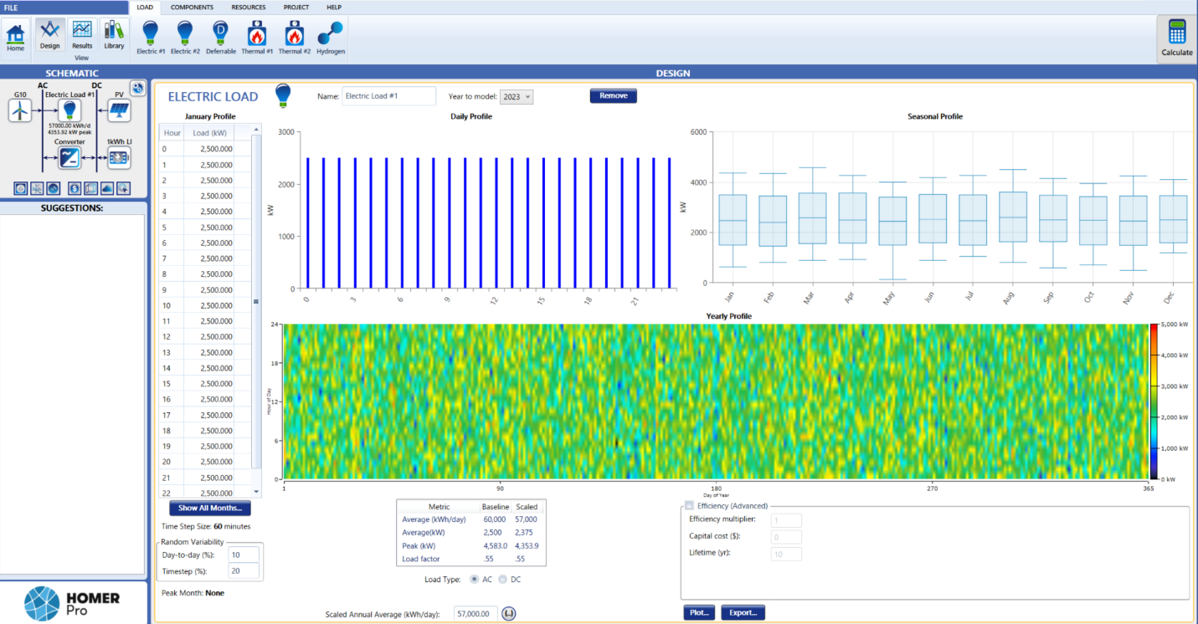

Screenshot of the Homer output:

|  |  |  |  |  |
| --- | --- | --- | --- | --- |
| Architecture/PV (kW) | Architecture/M-21 | Architecture/Gen (kW) | Architecture/1kWh LI (#) | Architecture/Converter (kW) |
| Solar,wind | 344 | 4800 | 33023 | 4014.651072 |



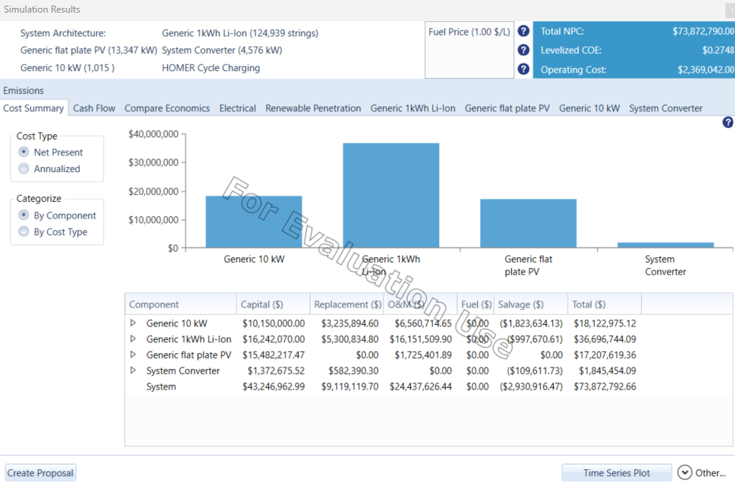

**Translating Homer's Outputs to MATLAB/Simulink**

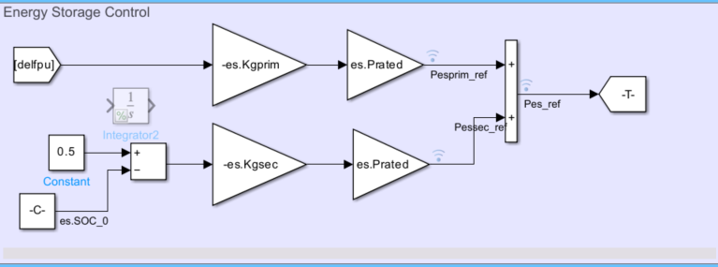

**Describe and demonstrate how you will translate the outputs of Homer to the MATLAB/Simulink parameters:**

By checking the output result from the homer we have got this parameters

meanLoad = 2500kW

es.Prated = 124,939kWH

es.Erated = 1.0795e+13

pv.Prated = 13,347kW

mg.Pbase (should be set to either peak or average load) = 4583

**Simulation Results:**

Simulate your system and plot the following:

Pload, Pwt, Ppv, Pes:

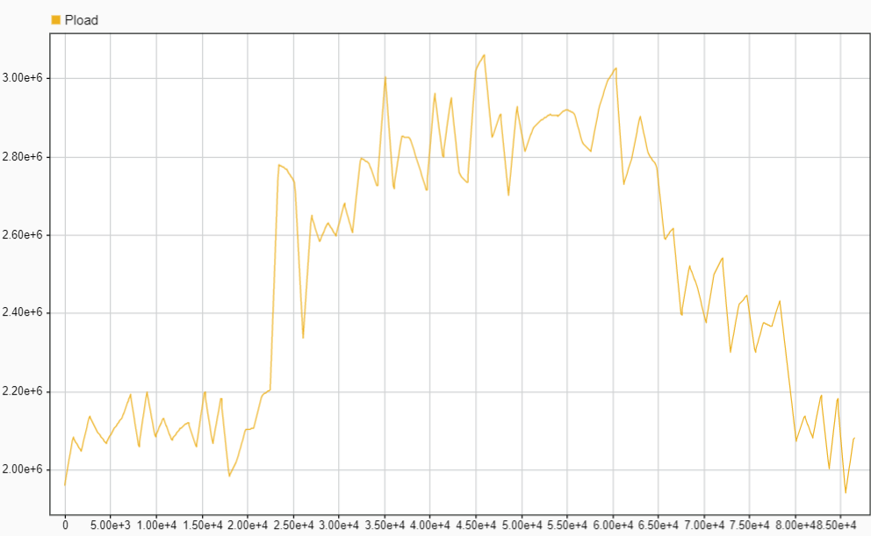

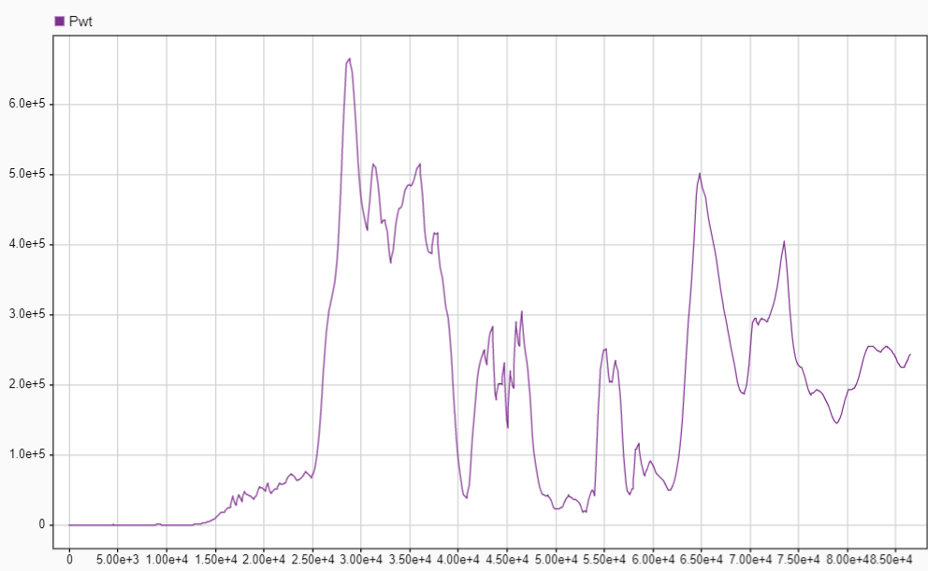

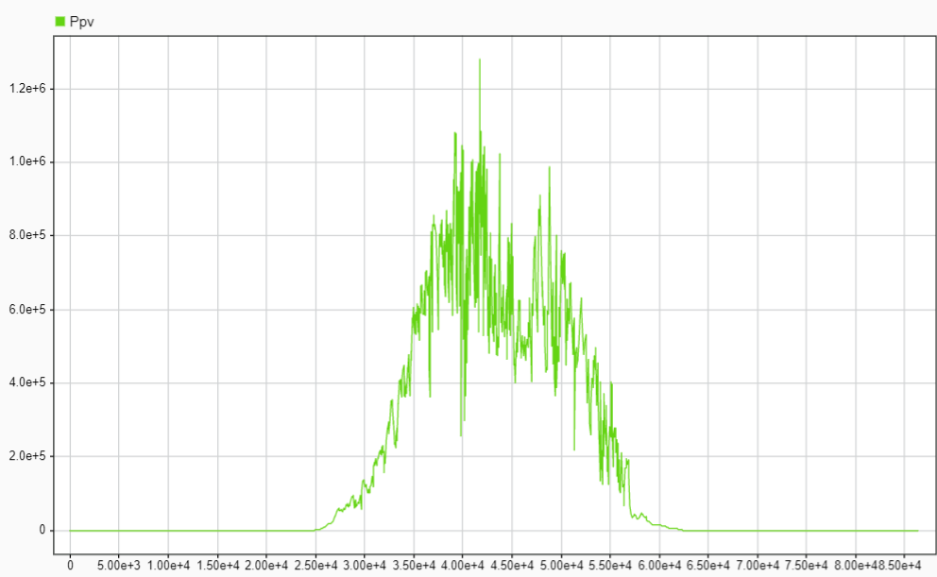

**Pes on left axis and SOC on right axis** 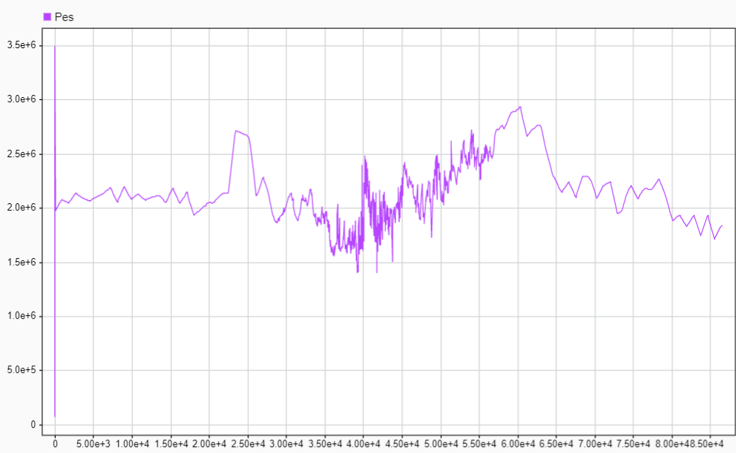

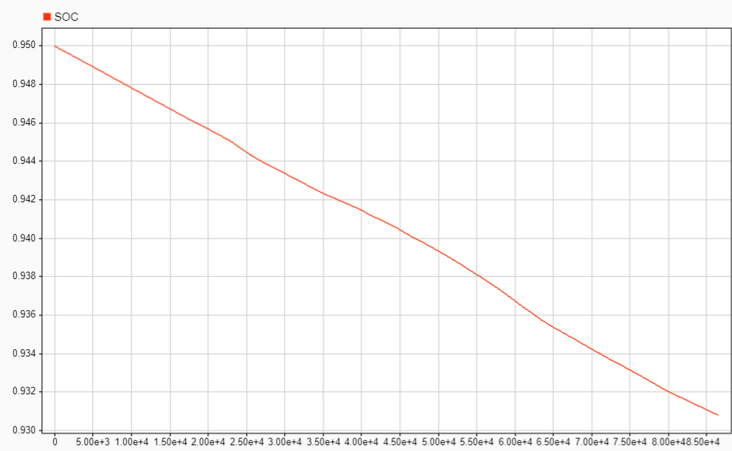

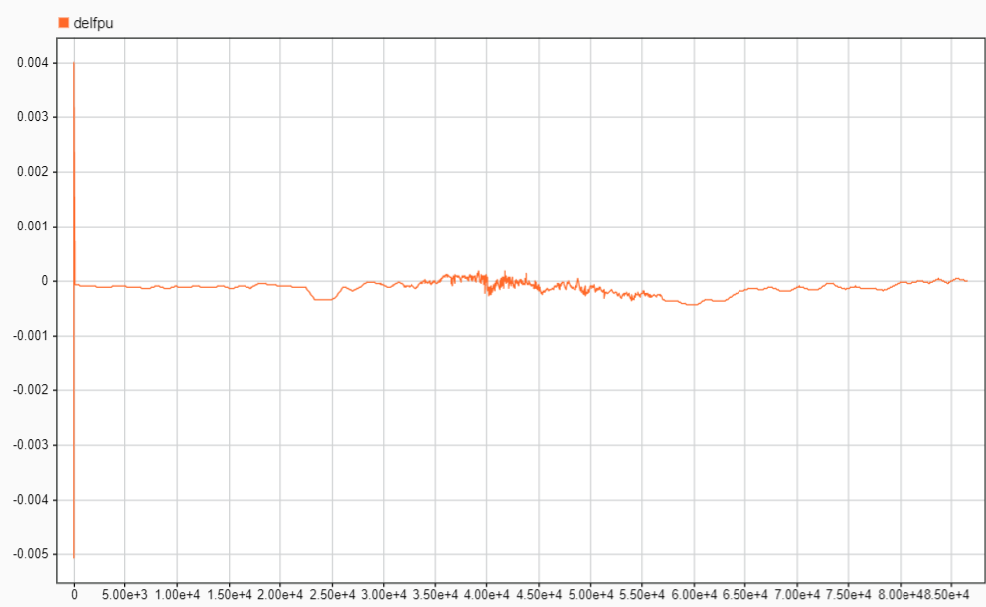

**Comment on if the design is stable:**

If we check the change in delfpu value throughout the simulation the value is in between +/- 0.10 so this makes the system to be a stable system because it stays close to nominal frequency without significant deviations.

**Make three additional comments on anything of interest in the performance of your microgrid:**

**Comment #1:**

The SOC is varying for different energy storage capacities, and we got the best use at 95 percent in our case which is declining in a steady manner, indicating that there are no sudden surges.

**Comment #2:**

The solar power output graph would exhibit variations throughout the day, with peaks during sunlight hours and lower output during the night. The solar panels' response to changes in irradiance levels and the MPPT (Maximum Power Point Tracking) algorithm would influence the power output.

**Comment #3:**

The Energy Storage (ES) system had demonstrated using an SOC graph, reflecting discharging cycle. During high load demand or low renewable energy availability, it would discharge. You might observe SOC oscillations and variations based on energy demand and supply conditions.

BOX LINK: https://oregonstate.box.com/s/urhcpbbz2v7t9xdlc11frgjdin4d2k9e